Day #16 – So how do I start getting paid from doing this?

Thanks for joining me at Day #16 of your FREE Govcon Dummies Course’.

I bet your wondering when can you start seeing money doing this?

In today’s lesson we are going to give you a few ideas how to start generating cash immediately.

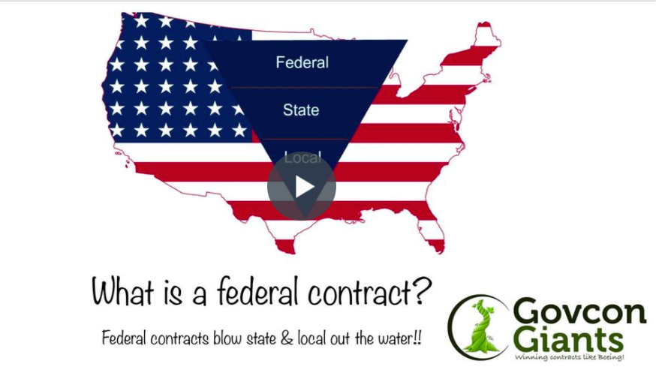
Take a look at a few ideas.

Trust me I know what it’s like to be desperate and low on cash. I went through turbulence during my growth stage.

But after some goal setting, I knew my NorthStar and wanted to head in that direction.

Where is your Northstar?

Start making money using these techniques

Big hug,

Eric Coffie

